PRESS RELEASE

IO-Link Safety Schmersal presents new safety solutions for the Smart Factory

Wuppertal, 25. November 2025. IO-Link Safety is establishing a new standard for functional safety in industrial automation. The technology transfers the principles of proven IO-Link communication to safety-related components and enables standardised, bidirectional communication right down to field level for the first time. Schmersal is one of the pioneers of this development and is presenting the AZM42 solenoid interlock and the RSS362 safety sensor, the first IO-Link safety products that will soon be available for delivery.

IO-Link Safety marks a turning point in industrial safety technology. The standardised communication path combines functionality and safety on one platform and creates the basis for intelligent, self-monitoring systems. This results in clear advantages for machine builders and operators: lower installation costs, greater transparency, faster diagnostics - and previously unrivalled flexibility," says Volker Heinzer, Strategic Product Manager for Industrial Communication and Industry 4.0 at the Schmersal Group.

Standardisation at an international level
The new interface meets the highest safety requirements in accordance with PL e (EN ISO 13849-1) and SIL 3 (IEC 61508/62061) and has been standardised in the international standard IEC 61139-2. This means that safety components from different manufacturers can work together interoperably - a milestone for Industry 4.0.

New products: AZM42 and RSS362
In addition to its compact design and high safety performance, the AZM42 solenoid interlock now also offers comprehensive diagnostic data in real time, for example on the supply voltage, temperature and RFID signal quality. The RSS362 non-contact safety sensor supplements these functions with intelligent diagnostic options and also supports secure bidirectional communication.

Both devices enable simple integration via standard three-wire cables with M12 connectors, thus reducing installation effort and costs. Thanks to the data storage function and offline configuration, maintenance and series production can be organised more efficiently.

IO-Link Safety as an enabler for smart production
The new products from Schmersal show: IO-Link Safety is not a vision of the future, but already a reality. Machine builders and operators benefit from greater transparency, faster diagnostics and previously unrivalled flexibility in the safety architecture.

With the introduction of the AZM42 and the RSS362, Schmersal is sending a strong signal for the further development of industrial safety technology - and emphasising its leading role in the IO-Link consortium.

Download printable photos:

Captions
Copyright: Schmersal Group
Note: Reprint free of charge - please send a voucher copy.

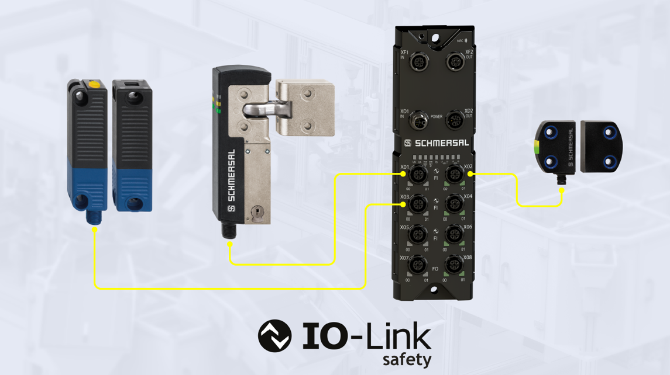

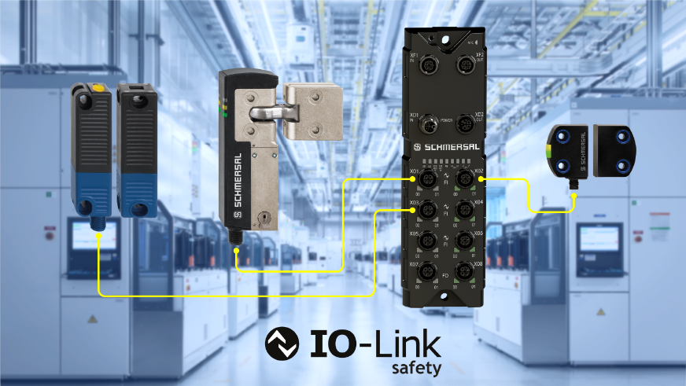

20251125_IOLS_01.jpg
20251125_IOLS_01a.jpg

The first IO-Link safety products from Schmersal will be available towards the end of the first half of 2026: the RSS362 safety sensor (right) and the AZM42 solenoid interlock (left) – further products such as the IO-Link safety master and the RSS262 sensor are in development.

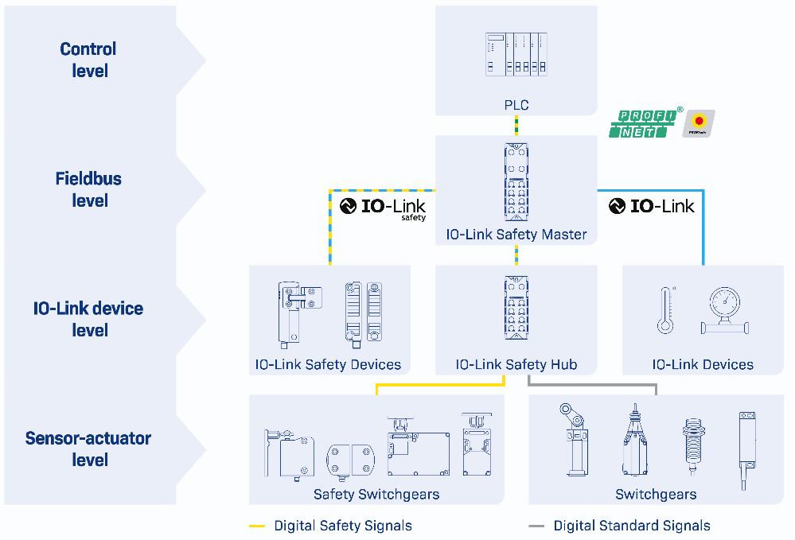
20251125_IOLS_03
Schematic representation of an IO-Link safety system architecture.

Contact:
Anke Siebold-Laux
Phone: + 49 202 6474-895
asieboldlaux@schmersal.com
K.A. Schmersal GmbH & Co. KG
Möddinghofe 30
42279 Wuppertal

The Schmersal Group
In the demanding field of machine safety the Schmersal Group is one of the international market and competence leaders. Based on the world's most comprehensive product portfolio of safety switching devices, the group develops safety systems and safety technology solutions for the special requirements of various user industries. Schmersal's solutions include the tec.nicum business division and its comprehensive range of services.
The company was founded in 1945, and is represented by eight manufacturing sites on three continents and with its own companies and sales partners in more than 60 countries. The Schmersal Group employs around 2000 people.

www.schmersal.com
www.tecnicum.com

If you would like to unsubscribe from our press mailing list and no longer receive press releases from Schmersal, simply click on this link:
Further information concerning the data protection policy of K.A. Schmersal GmbH & Co. KG can be found at here

