Press release

SCHMERSAL SOLENOID INTERLOCK AZM150

Compact security solution -
now with modular extensions

Wuppertal, 25. November 2025. The AZM150 from Schmersal is an electromechanical solenoid interlock. It is characterised by a slim, space-saving design and is versatile in use. With new additional components, the compact solenoid interlock gains additional versatility and impresses as a complete system with high cost-effectiveness.

A new feature is the rear-mounted push-button for escape release or emergency unlocking. The escape release makes it possible to leave the danger zone from the inside if a person is accidentally trapped in the danger zone. The emergency release allows the safety gate to be opened from the outside in the event of danger. The push-button is available in two versions: the 45 mm version for use with door handle thicknesses of e.g. 40 mm, which can be installed using the MP-AZM150-1 mounting plate, and the 170 mm version for use with door handle thicknesses of max. 170 mm or in conjunction with the DHS-150 door handle system.

Another new accessory for the AZM150 is the Bowden cable release with a total length of 6 metres, which enables remote release if the guard locking device cannot be installed in an inaccessible position. It is used to safeguard against particularly dangerous situations: If a person is accidentally trapped in a system, the Bowden cable can be used as an escape release. This is used as an emergency release if the guard locking must be unlocked from the outside in an emergency.

Versatile: rotatable actuator head
A plus point of the AZM150 guard locking is the rotating actuator head, which is locked in place by simply placing the cover instead of screwing it on. The 360° rotatable actuator head with its two actuator entries enables various mounting positions and approach options. This feature contributes to the versatility of the AZM150, which has a locking force of FZh = 1,500 N.

Switch with high coding
The AZM150 is an electromechanical solenoid interlock that is available with standard coding or highly coded as an I variant. It therefore offers excellent protection against tampering. The advantage for the user: with a high level of coding, fewer additional measures against tampering are required in accordance with ISO 14119.

Cost-effective complete system
With the new accessories, the series is now a complete system that covers a wide range of applications up to PLd/Kat3 and is also a very cost-effective solution. The AZM150 series is ideal for smaller machines and systems or
for cost-sensitive applications.

Download printable photos.
Captions
Copyright: Schmersal Group
Photographer: Dominik Gierke
Note: Reprint free of charge – please send a voucher copy.

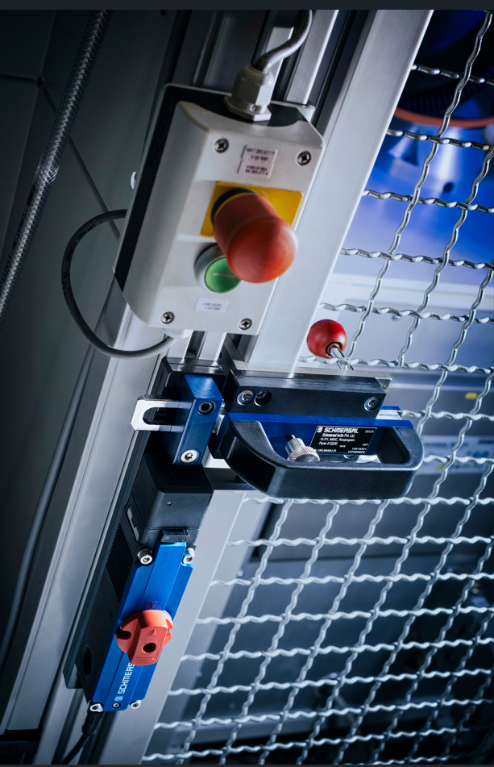

20251125_AZM150_01.jpg
The AZM150 - in this application combined with the DHS-150 door handle system - is an electromechanical solenoid interlock. It is available either standard-coded or highly coded as an I variant in accordance with ISO 14119.
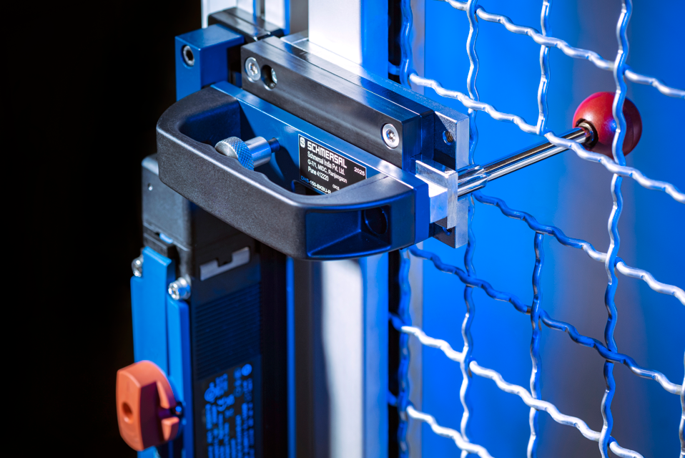
20251125_ AZM150_02.jpg
The DHS-150 door handle system is an ergonomic accessory that has been specially developed for the AZM150 solenoid interlock. It serves as a replacement for a separate door handle and is particularly suitable for machine enclosures, fencing and all standard door handles
Aluminium profiles with a width of 40 mm.
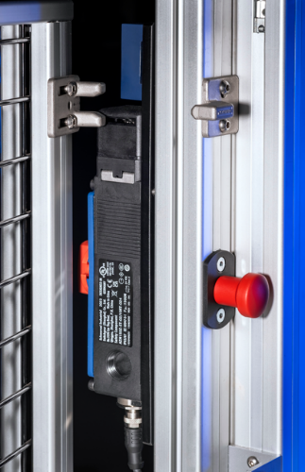
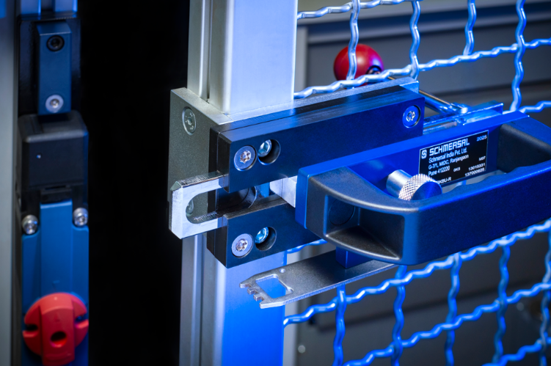

20251125_ AZM150_03.jpg
20251125_ AZM150_04.jpg
A plus point of the guard locking is the rotating actuator head, which is locked in place by simply replacing the housing cover instead of screwing it on. The 360° rotatable
Actuating head with its two insertion slots enables various mounting positions and approach options. After pressing the new push-button (AZM150-PT; on the right in the picture) in combination with the handle fitted on the inside, the door can be opened from the inside in an emergency
can be opened easily.

Contact:
Anke Siebold-Laux
Phone: + 49 202 6474-895
asieboldlaux@schmersal.com
K.A. Schmersal GmbH & Co. KG
Möddinghofe 30
42279 Wuppertal

The Schmersal Group
In the demanding field of machine safety the Schmersal Group is one of the international market and competence leaders. Based on the world's most comprehensive product portfolio of safety switching devices, the group develops safety systems and safety technology solutions for the special requirements of various user industries. Schmersal's solutions include the tec.nicum business division and its comprehensive range of services.
The company was founded in 1945, and is represented by eight manufacturing sites on three continents and with its own companies and sales partners in more than 60 countries. The Schmersal Group employs around 2,000 people.

www.schmersal.com
www.tecnicum.com

If you would like to unsubscribe from our press mailing list and no longer receive press releases from Schmersal, simply click on this link:
Further information concerning the data protection policy of K.A. Schmersal GmbH & Co. KG can be found at here

