Press release / PREVIEW SPS 2025

The Schmersal Group at SPS 2025:
Security, digitalisation and services optimally networked

Wuppertal, 03. November 2025. Networked systems, flexible manufacturing processes and digital technologies are setting new standards and posing completely new challenges for machine safety. At SPS 2025 in Nuremberg, the Schmersal Group will be demonstrating how safety technology can be intelligently networked to increase efficiency and productivity - and redefine safety in the process.

IO-Link Safety - new safety solutions for the Smart Factory
With the new IO-Link safety system, Schmersal presents an intelligent combination of functional safety and data transparency. Seamless communication between the machine and the control system reduces downtimes and increases efficiency to a new level. The planned market launch of the AZM42 solenoid interlock and the RSS362 safety sensor towards the end of the first half of 2026 will mark an important milestone for IO-Link safety applications. This makes the company one of the pioneers of IO-Link safety integration and emphasises its leading role in functional safety. Both devices extend Schmersal's IO-Link safety installation system for industrial safety applications and offer bidirectional, safe communication via a 3-wire cable. This allows safe applications up to performance level e, category 4 or SIL 3 to be realised – with a high degree of flexibility and simple integration into existing systems.
Digital twin with new possibilities
Schmersal is expanding its digital portfolio to include realistic 4D models of safety-related components, thus creating new possibilities for virtual machine planning. With digital twins of the AZM40 solenoid interlock, the DHS door handle system and the BDF40 control panel, safety-relevant functions can now be simulated in detail and integrated into digital development processes. A special milestone is the publication of the AZM40 model in the "TwinStore", an online marketplace for ready-to-use 4D simulation models. This innovation enables more efficient planning, virtual commissioning and practical training - a further step towards Industry 4.0.

New services from tec.nicum
The tec.nicum service division presents AI-supported security monitoring, digital lockout-tagout processes and innovative tools for energy optimisation. In combination with augmented reality applications, the experts will show how processes can be made safer, more efficient and future-proof.

SPS, Nuremberg: 25 to 27 November 2025
Schmersal: Hall 9, booth 460

Downloadable press-ready images

Captions
Copyright: Schmersal Group
Note: Reprint free of charge - please send a voucher copy.

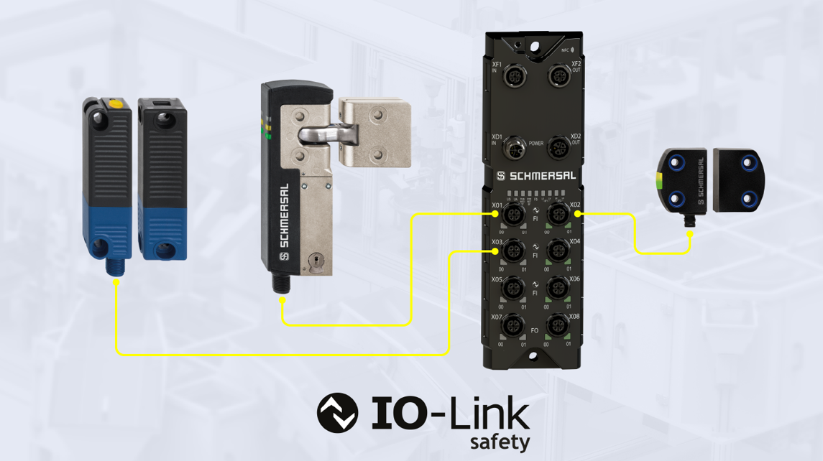

20251017_SPS_01.jpg

With the market launch of the RSS362 safety sensor (right) and the AZM42 solenoid interlock (left), Schmersal is setting new standards in IO-Link safety integration. Further products such as the IO-Link safety master and the RSS262 sensor are planned for the next expansion stage.

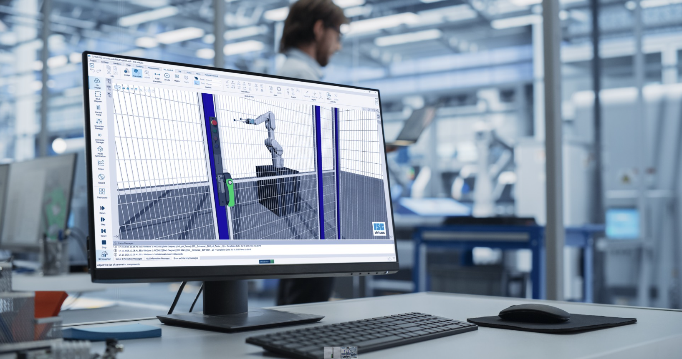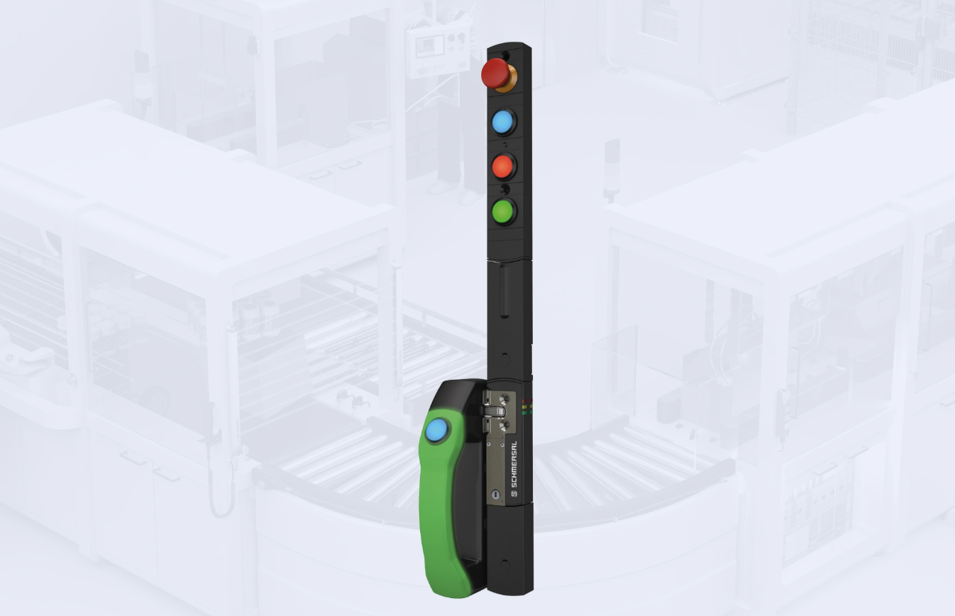

20251017_SPS_02.jpg
20251017_SPS_03.jpg
Schmersal offers 4D models in the TwinStore that can be connected to a real control system via a real-time target. This makes it possible to precisely simulate the virtual commissioning of machines and systems.

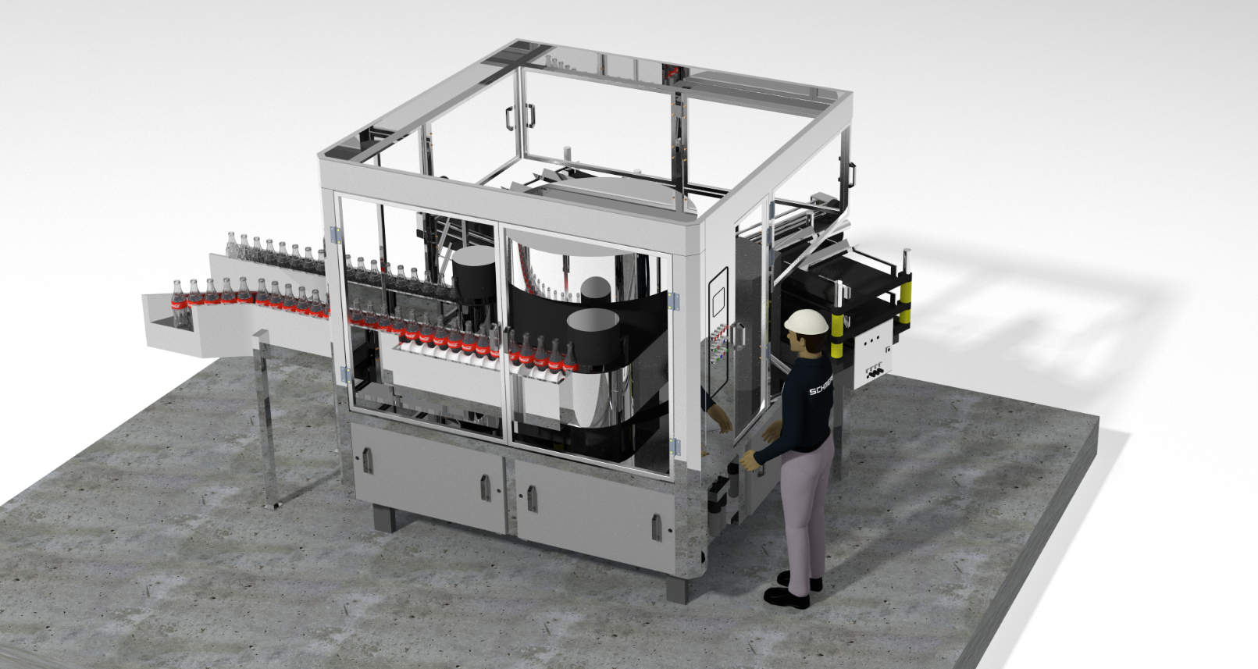

20251017_SPS_04.jpg
At this year's SPS, tec.nicum will be showcasing practical solutions for machine and plant safety, digitalisation and outsourcing - from innovative engineering tools and 3D visualisations to turnkey solutions and comprehensive all-round service.

Contact:
Anke Siebold-Laux
Phone: + 49 202 6474-895
asieboldlaux@schmersal.com
K.A. Schmersal GmbH & Co. KG
Möddinghofe 30
42279 Wuppertal

The Schmersal Group
In the demanding field of machine safety the Schmersal Group is one of the international market and competence leaders. Based on the world's most comprehensive product portfolio of safety switching devices, the group develops safety systems and safety technology solutions for the special requirements of various user industries. Schmersal's solutions include the tec.nicum business division and its comprehensive range of services.
Founded in 1945, the company has eight production sites on three continents as well as its own companies and sales partners in more than 60 countries. The Schmersal Group employs around 2,000 people worldwide.

www.schmersal.com
www.tecnicum.com

If you would like to unsubscribe from our press mailing list and no longer receive press releases from Schmersal, simply click on this link:
Further information concerning the data protection policy of K.A. Schmersal GmbH & Co. KG can be found at here

