Press Release

In 2026, Schmersal is ranked among the best employers in North Rhine-Westphalia and the industrial sector – awards from Great Place to Work confirm the company’s culture of mutual respect

Wuppertal, 26 March 2026. K.A. Schmersal GmbH & Co. KG is ranked among the best employers in Germany in 2026. The family-run company has recently received two awards from the research and consultancy institute Great Place to Work: Schmersal came sixth in the ‘Best Employers in North Rhine-Westphalia’ competition, and fourth in the sector ranking ‘Best Employers in Manufacturing and Industry 2026’.

The awards are based on an anonymous employee survey and an analysis of the company’s HR and management practices. Factors assessed include trust in leadership, team spirit, appreciation, working conditions and development opportunities.

Schmersal uses the results specifically to implement improvements in everyday working life. Measures taken in recent years include height-adjustable desks for all employees with a PC workstation, health campaigns, team-building workshops, sustainability initiatives, and training on leadership development and agile working.

‘These awards are a special endorsement of our corporate culture,’ says Dr Anna Dahlem, Head of People and Culture at Schmersal. ‘We are particularly pleased that the positive feedback comes directly from our employees. It shows that our measures to further develop working conditions and collaboration are bringing about tangible improvements.’

International multiple certifications
The Schmersal Group has also received multiple awards internationally as an attractive employer; among others, its subsidiaries in Brazil, France, India, Italy, Sweden, Shanghai, Spain, and the USA recently received GPTW certifications.

‘With the national and international awards, we confirm our ambition to promote attractive working conditions and an appreciative corporate culture worldwide,’ summarises Dr Anna Dahlem, reflecting the Schmersal Group’s self-image.

Download printable photos.
Captions
Copyright: Schmersal Group
Note: Reprint free of charge - please send a voucher copy.
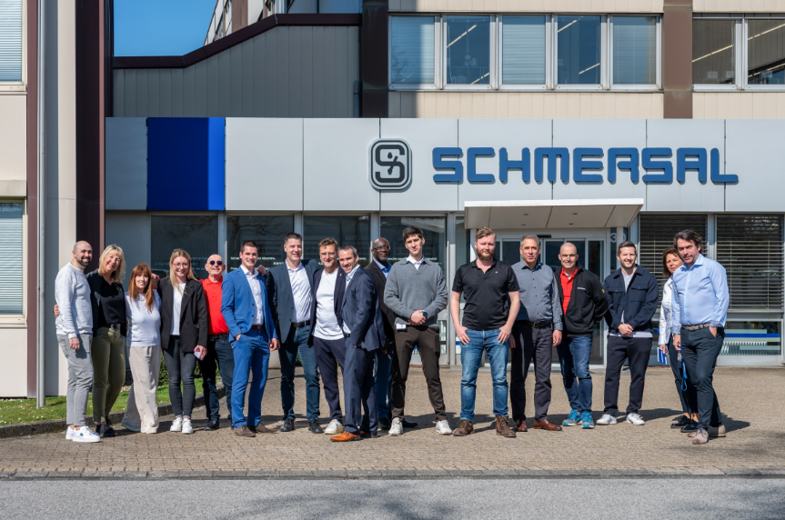
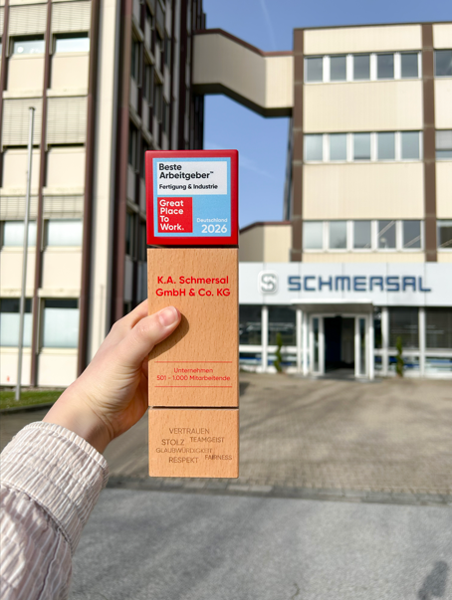

20260326_GPTW2026_1.jpg
20260326_GPTW2026_2.jpg
Schmersal was recognised in the ‘Best Employers in North Rhine-Westphalia’ competition and in the sector ranking ‘Best Employers in Manufacturing and Industry 2026’.

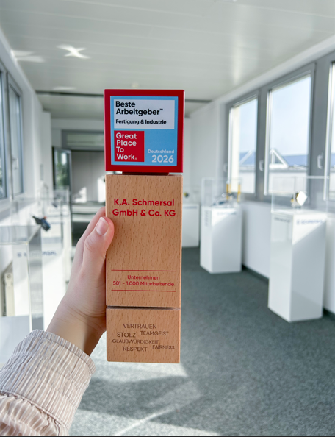

20260326_GPTW2026_3.jpg
In the ‘Best Employers in North Rhine-Westphalia’ competition, Schmersal came sixth, and in the sector ranking ‘Best Employers in Manufacturing and Industry 2026’, the company achieved fourth place.



20260326_GPTW2026_4.jpg
Dr Anna Dahlem, Head of People and Culture, K.A. Schmersal GmbH & Co. KG

Contact:
Anke Siebold-Laux
Tel.: + 49 202 6474-895
asieboldlaux@schmersal.com
K.A. Schmersal GmbH & Co. KG
Möddinghofe 30
42279 Wuppertal
Germany

The Schmersal Group
In the demanding field of machine safety the Schmersal Group is one of the international market and competence leaders. Based on the world's most comprehensive product portfolio of safety switching devices, the group develops safety systems and safety technology solutions for the special requirements of various user industries. Schmersal's solutions include the tec.nicum business division and its comprehensive range of services.
The company was founded in 1945, and is represented by eight manufacturing sites on three continents and with its own companies and sales partners in more than 60 countries. The Schmersal Group employs around 2000 people.

www.schmersal.com
www.tecnicum.com

If you would like to unsubscribe from our press mailing list and no longer receive press releases from Schmersal, simply click on this link:
Further information concerning the data protection policy of K.A. Schmersal GmbH & Co. KG can be found at here

