Press Release
New Schmersal Webshop: faster, simpler, fully responsive

Wuppertal, Germany, May 6, 2026. K.A. Schmersal GmbH & Co. KG has successfully launched its new webshop. With modern technology and significantly improved user guidance, the platform offers customers worldwide a more convenient and efficient shopping experience for products, order data, and services. The overall portfolio comprises around 15,000 products in safety, control, and automation technology.

Significantly simplified ordering and registration process
A key focus of the relaunch was further improving user-friendliness. The entire ordering process has been made clearer and more intuitive. Existing approval processes for the registration of business customers have been retained but now run more efficiently. Another advantage for existing customers: current login credentials remain valid, ensuring a seamless transition to the new system.

Product information presented more clearly and technically
The product detail pages are now more user-friendly: technical features, specifications, and relevant information are more prominently displayed and easier to find. Additional functions such as a product comparison tool further support customers in selecting suitable solutions.

Responsive Design
The mobile experience has also been significantly improved. The new webshop now features a modern, responsive design. Content and functions automatically adapt to different devices, ensuring convenient use on the go.

International availability and personal support
The new webshop is available in around 20 countries, strengthening Schmersal’s international digital presence and providing a consistent global shopping experience. In addition to digital optimization, Schmersal continues to focus on personal support. Customers will still benefit from technical and commercial support hotlines to receive fast and competent assistance.

Webshop: www.products.schmersal.com

Image available for download:

Caption
Copyright: Schmersal Group
Note: Free for publication – copy requested

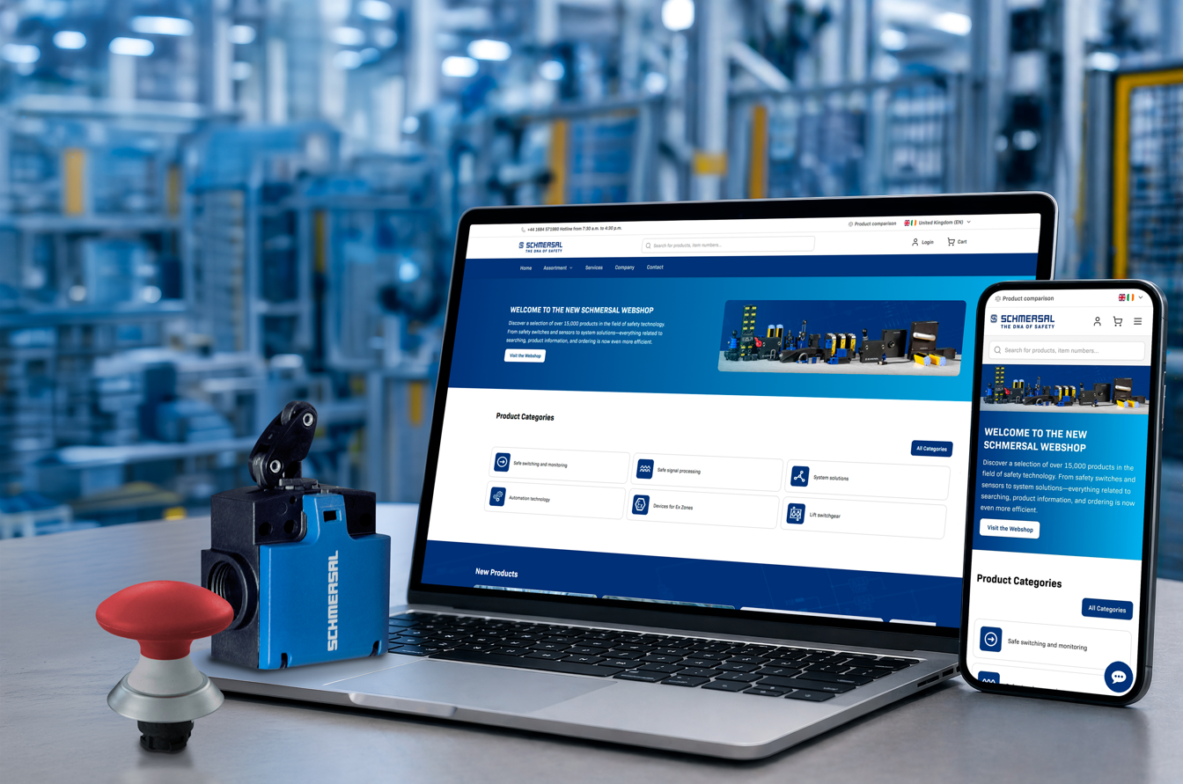
20260506_Webshop2026_01.jpg
With the new webshop, Schmersal is consistently investing in its digital future and offering customers worldwide modern, high-performance, and user-friendly access to its product portfolio. Webshop: www.products.schmersal.com

Contact:
Anke Siebold-Laux
Phone: + 49 202 6474-895
asieboldlaux@schmersal.com
K.A. Schmersal GmbH & Co. KG
Möddinghofe 30
42279 Wuppertal

The Schmersal Group
In the demanding field of machine safety the Schmersal Group is one of the international market and competence leaders. Based on the world's most comprehensive product portfolio of safety switching devices, the group develops safety systems and safety technology solutions for the special requirements of various user industries. Schmersal's solutions include the tec.nicum business division and its comprehensive range of services.
The company was founded in 1945, and is represented by eight manufacturing sites on three continents and with its own companies and sales partners in more than 60 countries. The Schmersal Group employs around 2000 people.

www.schmersal.com
www.tecnicum.com

If you would like to unsubscribe from our press mailing list and no longer receive press releases from Schmersal, simply click on this link: Unsubscribe Further information concerning the data protection policy of K.A. Schmersal GmbH & Co. KG can be found at here

